* You have to install docker and jenkins in your system from your terminal using package managers

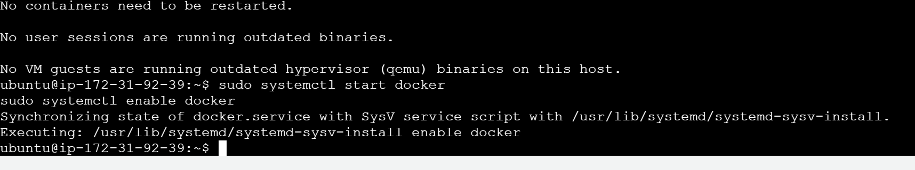

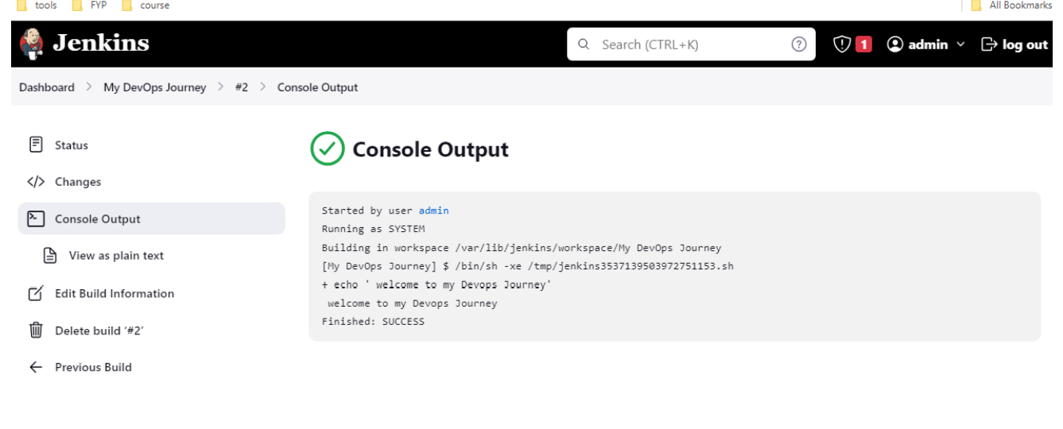

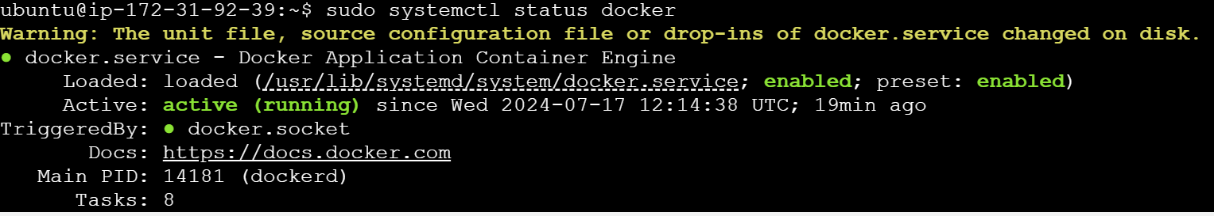

* read about the commands systemctl vs service

An older command that works with sysvinit, a traditional service management system.

Provides basic service management functionality like starting, stopping, and querying services.